## Ideas generation

Idea generation is an integral part of any design process. It is a skill that is honed over time and allows a designer to access their creative potential at a moment's notice. The ability to develop and explore ideas is a skill that can make a creative professional stand out from the crowd. It exemplifies the expertise of a professional designer. Professional creatives must hone and maintain their ability to experiment, explore and develop new ideas. Idea generation techniques are used by furniture designers, graphic designers, garden designers, marketing professionals, interior designers, fashion designers, architects, writers, scientists, political strategists, photographers, artists, etc. The number of professions that require techniques to develop ideas is endless but the critical thing to discover for yourself, are the techniques that work best for you as a creative individual.

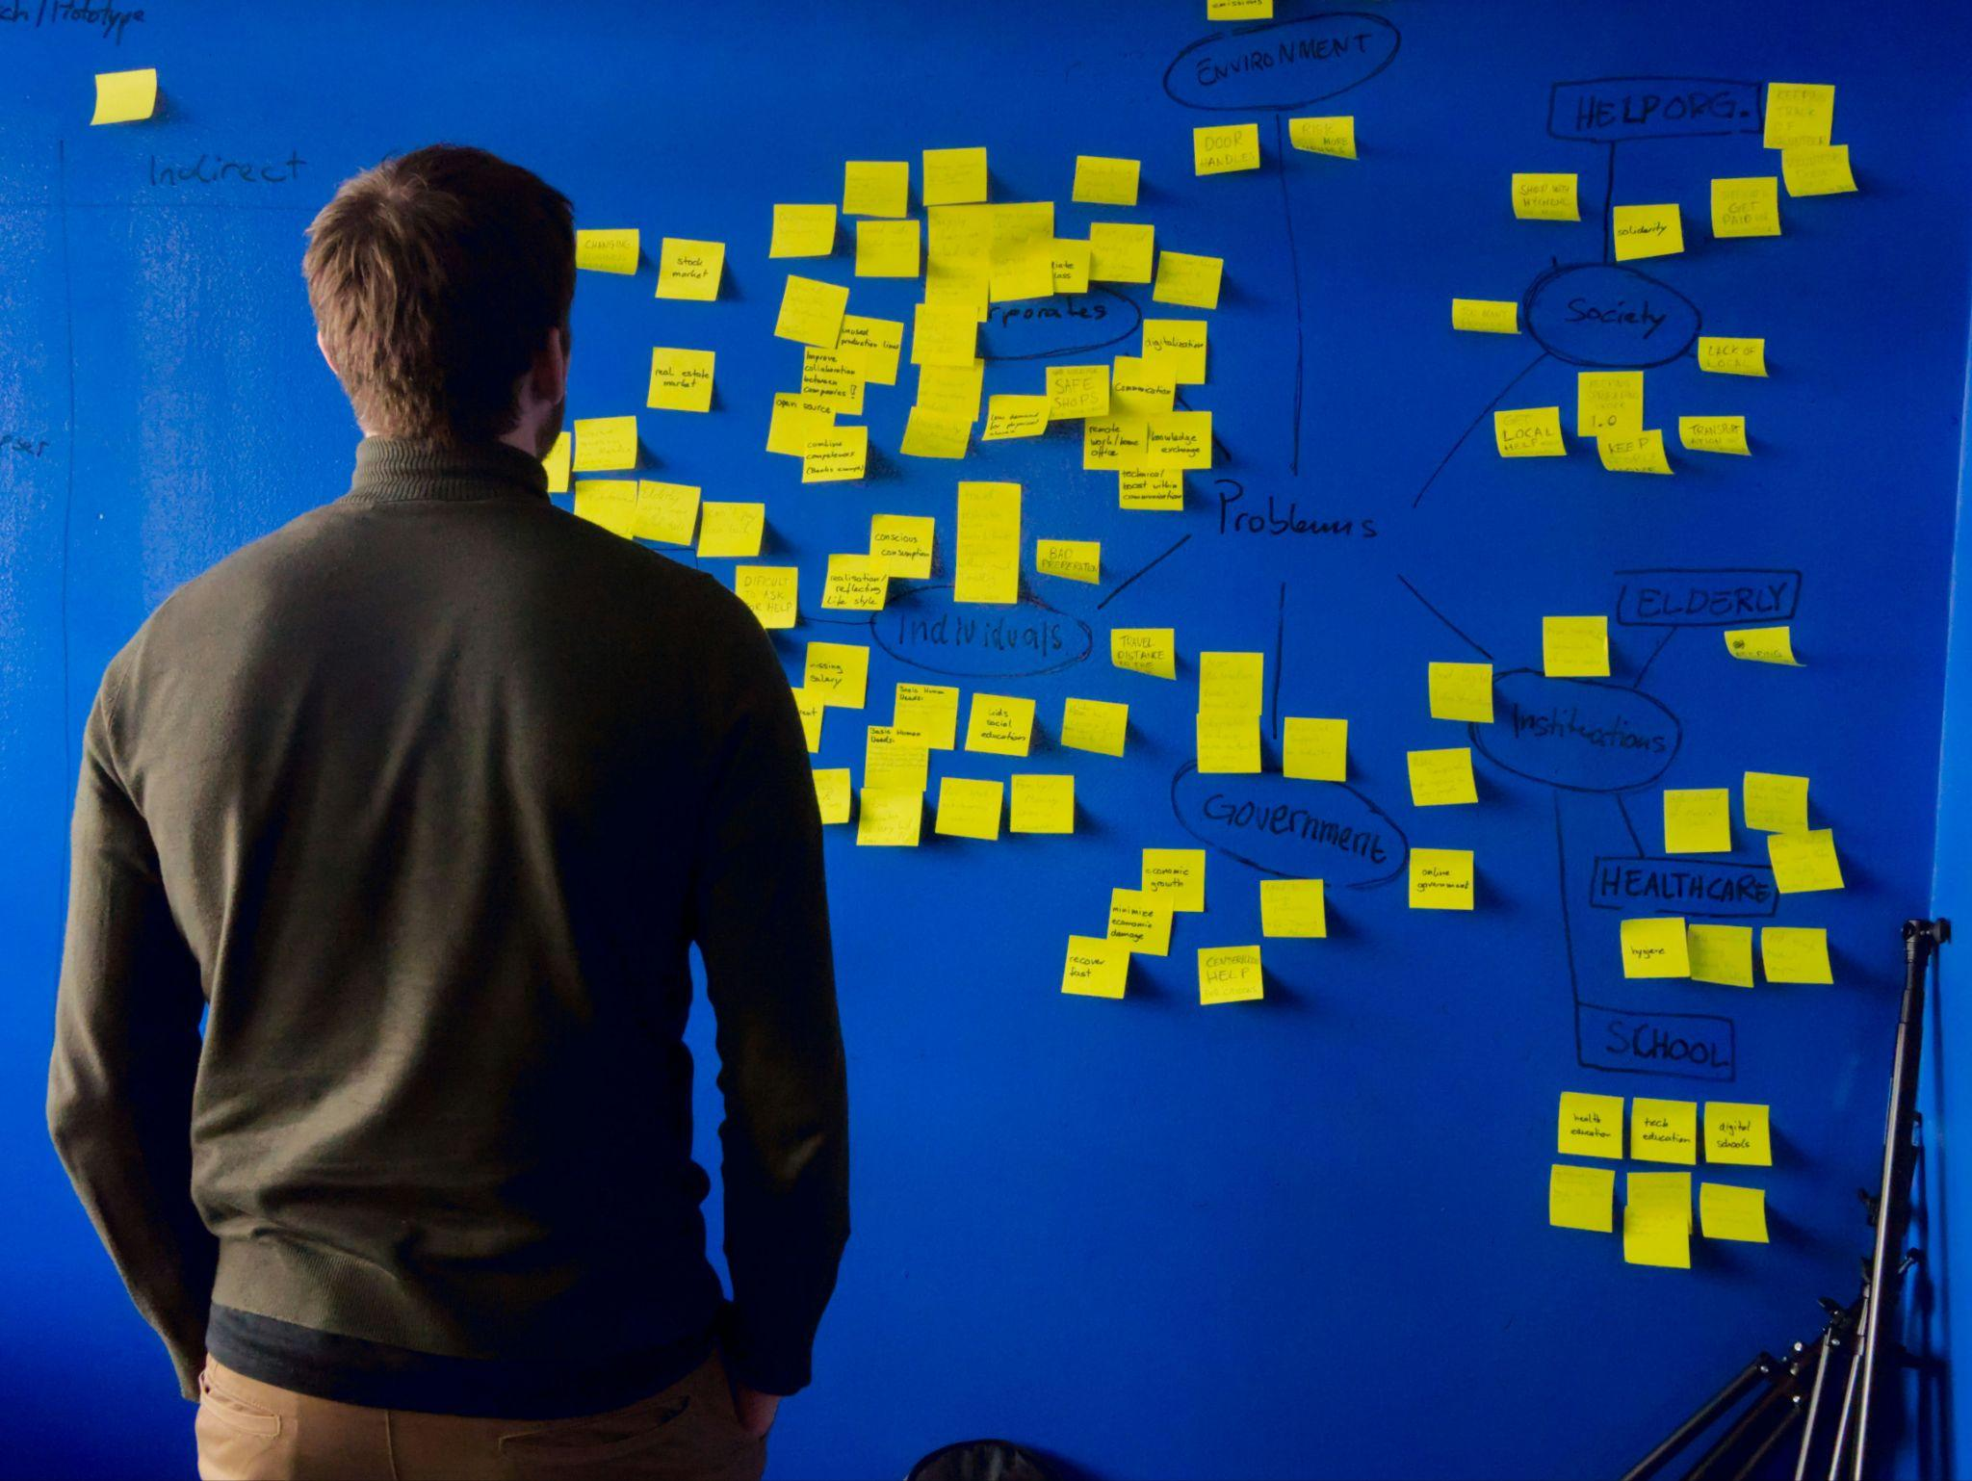

Fig 1. Unsplash (n.d.) Idea generation

If you are a naturally creative person it may at first seem unnecessary to pay special attention to idea generation techniques. Many people do have an intuitive sense of developing innovative ideas but even the most instinctively creative among us, need to develop the skill of idea generation. When creativity is a part of your profession, it is essential to possess the ability to come up with good, innovative ideas even when you are not feeling very inspired. There will be occasions in your career when you do not have an immediate idea or direction to take on a project, task, or problem. However, with a skilled ability to generate creative ideas, there will never be a need to fear the blank page. It is for these reasons that it is vital to practise idea generating techniques.

### Simulation and role-playing

Simulation and role-playing can be effective idea generation techniques in design, especially when creating user-centric solutions or designing for specific user experiences. Simulation and role-playing involve putting yourself in the shoes of your end-user so you can simulate real-life scenarios and gain insights, generate ideas, and validate design concepts.

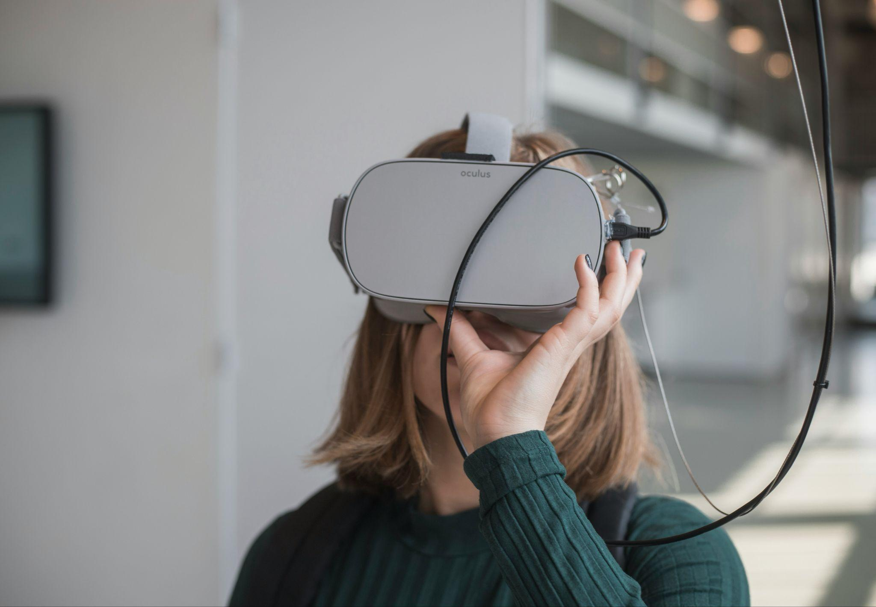

Fig 2. Unsplash (n.d.) VR is a good way to generate simulations

#### Scenario Creation

Simulation involves creating user scenarios that depict typical interactions and experiences with a product. In digital design, this could be a website or an app. For example, if you need to design an educational app, designers will need to envision scenarios such as a student completing a social studies quiz, a teacher assigning maths homework, or a parent tracking their child's progress.

#### Role-Playing Sessions

Role-playing is not unlike simulation in that it attempts to create an experience similar to that of a user to better understand a target audience. The team of designers may do this by conducting role-playing sessions where team members assume different roles. So again with an educational app, team members could assume roles such as students, teachers, and parents. The aim is for each participant to immerse themselves in the respective roles and act out various scenarios from those perspectives. One team member might role-play as a young student using the app to solve subject-related problems, while another might act as a teacher providing feedback and guidance. The interactions will allow app developers and the designers to notice aspects that could have a crucial impact on the success of the app, like its features, general functionality, navigating the app itself etc.

### Forced relationships

Forced relationships, also known as forced connections or forced associations, are a creative thinking technique used in various design disciplines to generate new ideas. It involves combining one or more unrelated or *seemingly* unrelated concepts, objects, or elements together to make a new combination. This technique encourages designers to think outside the box, breaking themselves free from conventional thinking patterns, and exploring unexpected connections between elements. In the food world, it’s like fusion cooking or the invention of the delicious cronut that evolved from the marriage between a croissant and a doughnut.

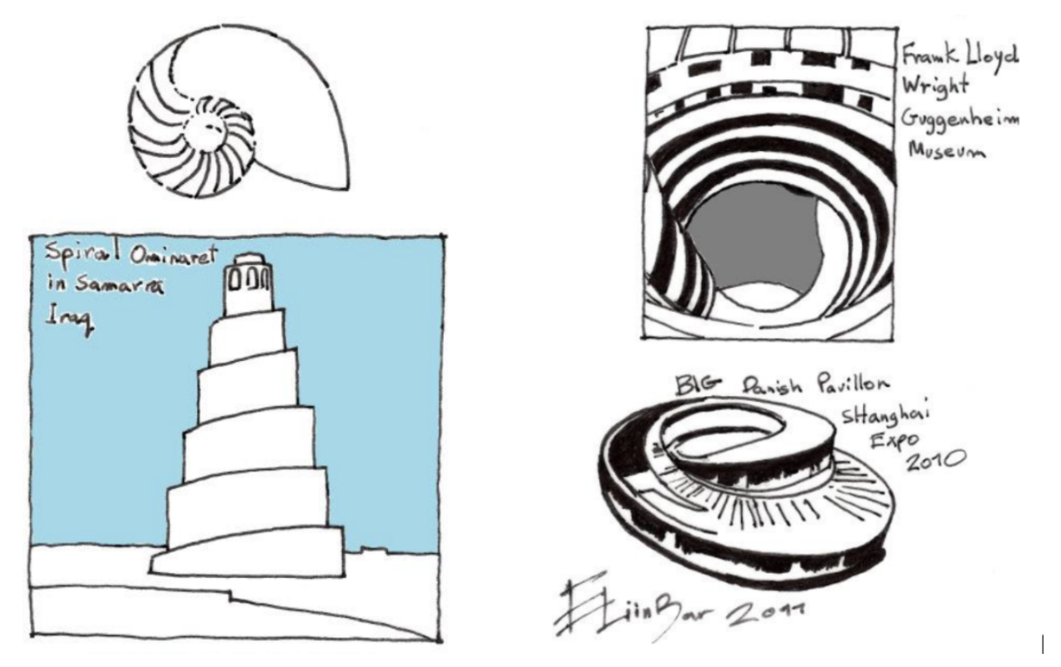

Fig 3. Architecture inspired by a sea shell - two unrelated subjects

Say for example you are designing a new smartphone interface. You could force a relationship between traditional navigation systems (e.g. compass, map) and natural elements (e.g. wind, water). This forced relationship might inspire a navigation interface that uses fluid, organic movements reminiscent of water flow or wind patterns to guide users through the interface

### Thinking Hats

The "Thinking Hats" technique, developed by Dr. Edward de Bono, is another powerful tool for facilitating creative thinking, solving problems, and making decisions. This technique encourages designers to approach a problem or situation from different perspectives and put on their proverbial ‘thinking caps’. The six thinking hats represent six metaphorical hats of different colours, each representing a different mode of thinking, allowing participants to explore a problem from multiple angles and generate a variety of ideas.

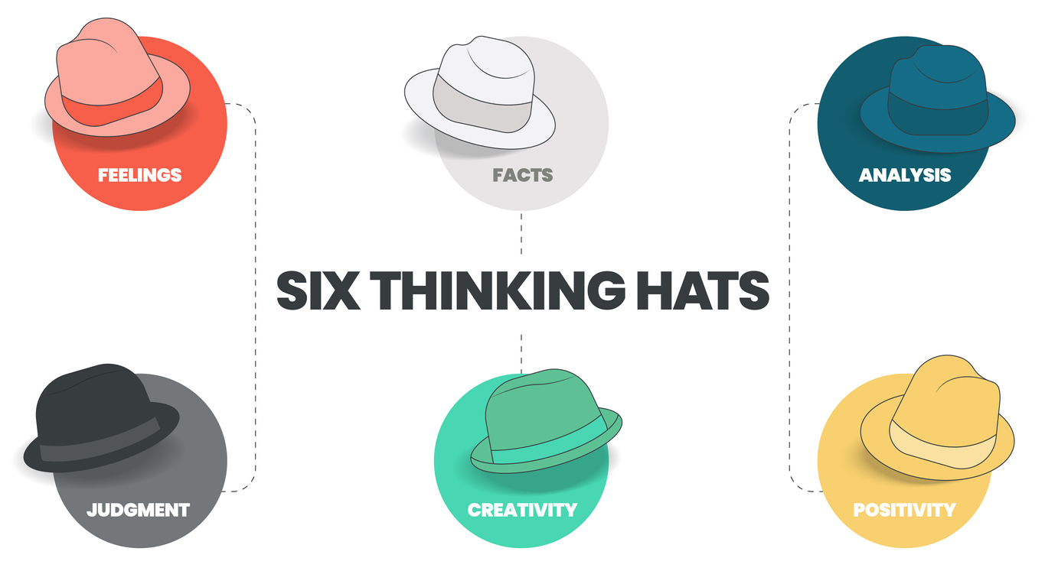

Fig 4. Bono’s Six Thinking Hats

#### White Hat

The White Hat focuses on facts. This is made up of information and data related to the problem or design challenge. They are basically, objective facts. As a designer, when you wear the White Hat, you gather and analyse relevant information, identify gaps in knowledge, and clarify any uncertainties or assumptions.

In the design process, the White Hat requires you to gather user research, market data, technical specifications, and other factual information relevant to the project.

#### Red Hat

The Red Hat represents emotions, feelings, and intuition. It allows designers to express their gut reactions, instincts, and emotional responses to a particular problem. When wearing the Red Hat, designers or focus group participants, for example, share their emotional responses without needing to justify or rationalise them. This encourages honesty, empathy, and intuition.

During the design process, the Red Hat can be used to consider how users might emotionally respond to a design solution, identify potential pain points or frustrations, and explore opportunities for creating meaningful connections with users.

#### Black Hat

The Black Hat represents critical thinking, scepticism, and caution. It focuses on identifying potential risks, weaknesses, and obstacles associated with a specific design solution. When wearing the Black Hat, designers analyse the design solution from a very critical perspective, highlighting potential drawbacks, limitations, and areas for improvement. In the design process, you can use the Black Hat to conduct risk assessments, identify potential design flaws or usability issues, and anticipate challenges that may arise during implementation or use.

#### Yellow Hat

The Yellow Hat represents optimism, positivity, and constructive thinking. This ‘hat’ encourages you to focus on identifying opportunities, strengths, and potential benefits associated with a design solution. When wearing the Yellow Hat, designers highlight the positive aspects of the design solution, including its strengths, advantages, and potential value to users and stakeholders. The Yellow Hat is best used to explore opportunities for innovation, to identify strengths and unique selling points of a design solution, and to inspire confidence in its potential success.

#### Green Hat

The Green Hat represents creativity, brainstorming, and ideas generation. It encourages designers to think creatively, and explore new possibilities. When wearing the Green Hat, designers engage in brainstorming sessions, ideation exercises, and creative thinking techniques to generate a wide range of ideas and alternatives. You can also use the Green Hat to explore new design concepts, experiment with different approaches, and push the boundaries of conventional thinking to generate innovative solutions.

#### Blue Hat

The Blue Hat serves as the control hat, overseeing the thinking process and facilitating communication and collaboration among participants or designers. When wearing the Blue Hat, you manage the flow of the discussion, set objectives and agendas, establish ground rules, and guide the group towards achieving its goals. This ‘hat’ is typically worn by a project manager.

In the design process, the Blue Hat can be used to facilitate brainstorming sessions, structure design workshops, manage time and resources effectively, and ensure that the thinking process remains focused and productive.

### Lateral thinking

Lateral thinking, also coined by Edward de Bono, is a creative thinking technique that encourages individuals to approach problems and generate ideas from unconventional perspectives. Strictly speaking, the six Thinking Hats technique is an example of lateral thinking. But there are also other ways to think outside of the box.

Unlike vertical or logical thinking, which follows a linear path of reasoning, lateral thinking involves exploring alternative pathways, making unexpected connections, and challenging assumptions.

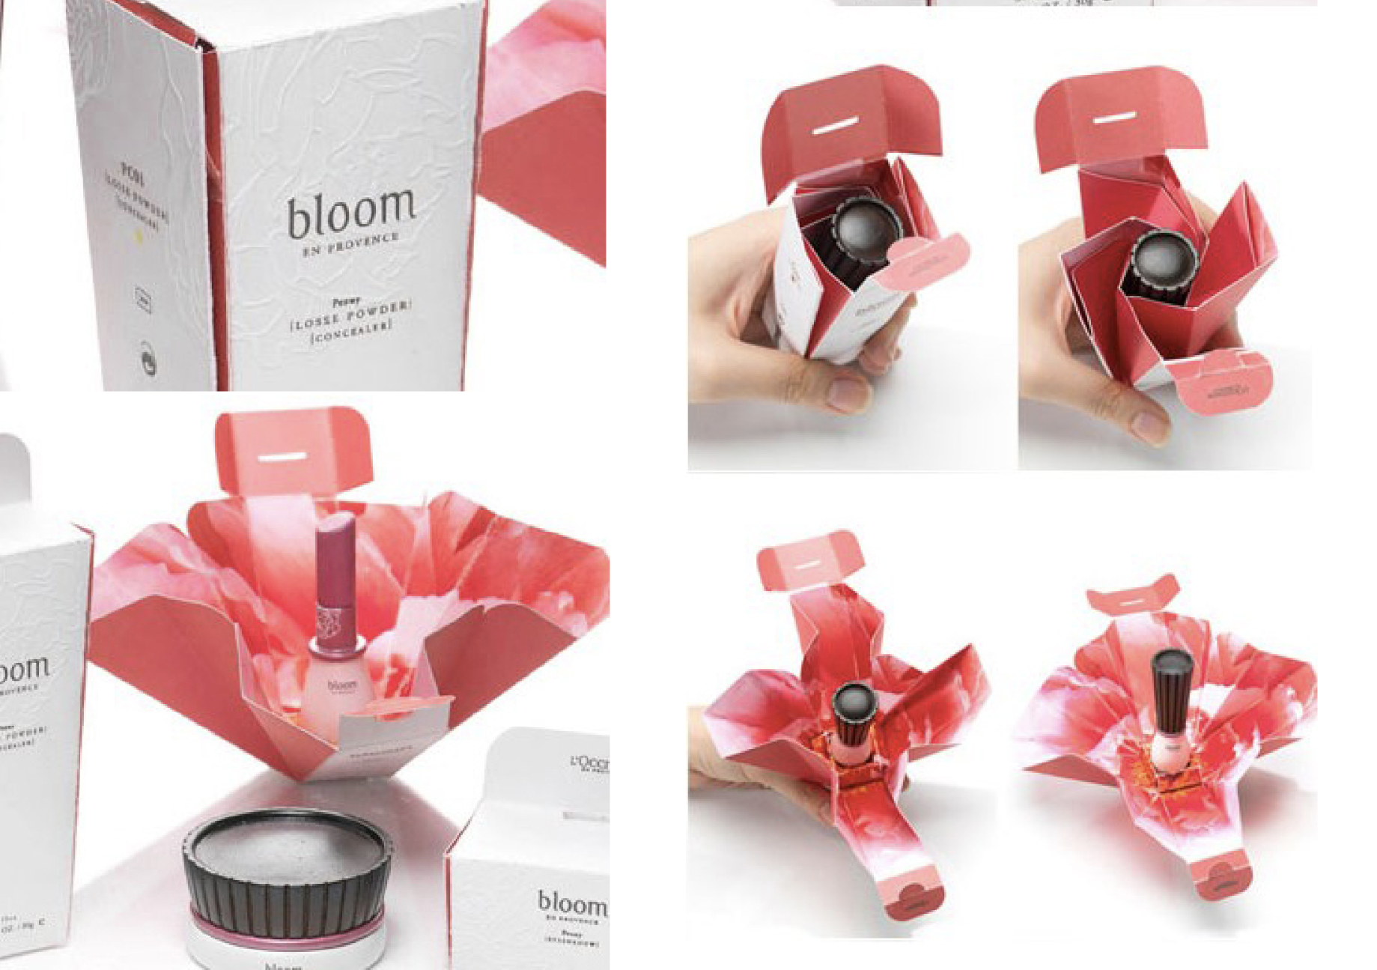

Fig 6. Innovative packaging generated through lateral thinking

Lateral thinking involves the following:

* **Challenging assumptions and preconceived notions** about the problem or design. By challenging established beliefs and assumptions, you can break free from conventional thinking patterns and explore new possibilities or solutions.
* **Generating and asking provocative questions** to challenge conventional wisdom and stimulate unconventional ideas. For example, instead of asking, "How can we improve the existing design?" you might ask, "What if our design was aimed at a completely different audience or purpose?"
* **Making analogies and metaphors** encourages connections between unrelated concepts, objects, or ideas. Drawing parallels between seemingly disparate elements, allows you to uncover new insights and generate innovative solutions. For instance, you might draw inspiration from nature, music, art, literature, or everyday objects to generate ideas for solving a design problem.
* **Combining ideas, concepts, or techniques from different domains** or disciplines to create novel solutions can create fresh perspectives and innovative approaches to design problems. For example, you might draw inspiration from architecture, biology, psychology, or technology.
* **Using provocative techniques and creativity tools** to stimulate idea generation and problem-solving, such as random stimulation, reversal, exaggeration, and forced connections. This can disrupt conventional thinking patterns and spark creative breakthroughs. For instance, you might use the "random word" technique, where you randomly select a word and brainstorm ideas based on associations with that word, that might generate solutions to a design challenge.
* **Encouraging playfulness and experimentation** allows you to feel free to explore unconventional ideas and take risks. By embracing ambiguity, uncertainty, and failure, you can discover unexpected solutions and discoveries. You might engage in activities such as doodling, sketching, role-playing, or improvisation to stimulate creativity and generate new ideas.